Lok Sabha -2024 Survey Insights

* Based on Survey Result, BJP is winning party.
* Satisfaction level with BJP government is 67% percent among people.

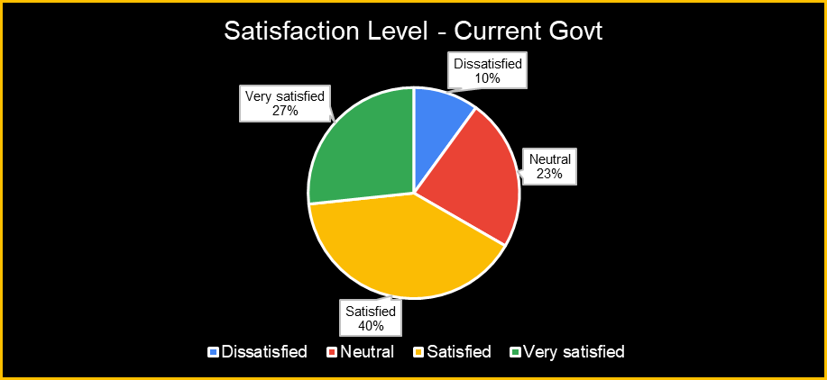

* People expect the Govt to be more focused on Job Creation which is somehow people feel Govt is lacking behind.

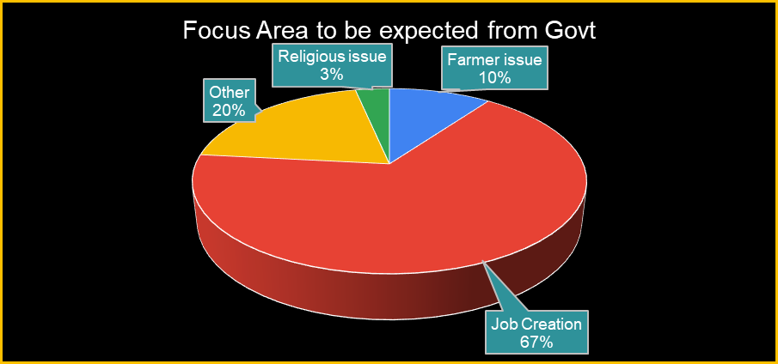

* People believe that PM Modi did well to save our Indian Economy when other Country Economy is not doing well.

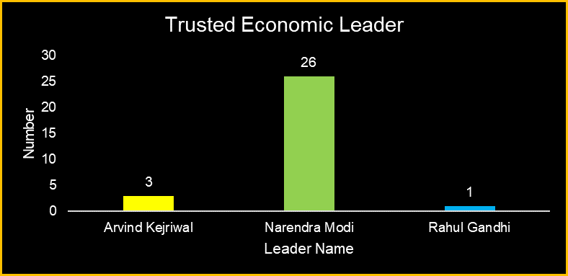

* 60 percent of people think the election is always part of transparent without any flaws.

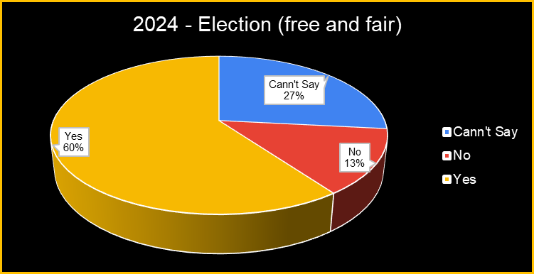

* People are not sure that CBI is taking action on opposition Party is influence by Government.

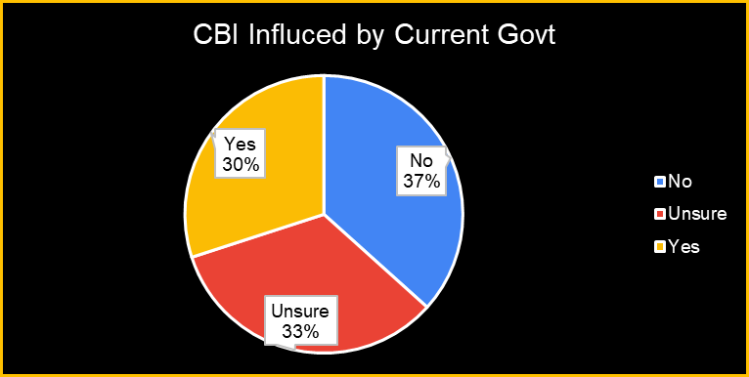

* Survey result says that Current Govt has improved infrastructure significantly.

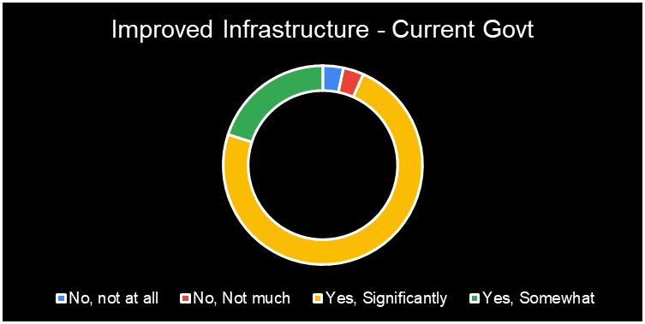

* Survey result shows that the top factor of Vote is National issues and Party Leadership.

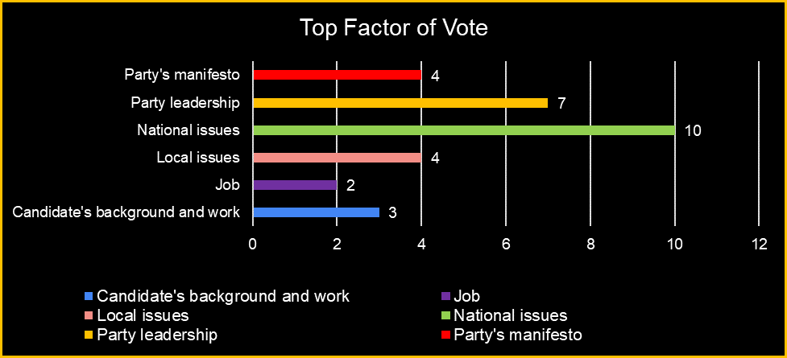

* 73 percent people says that BJP has best Manifesto.

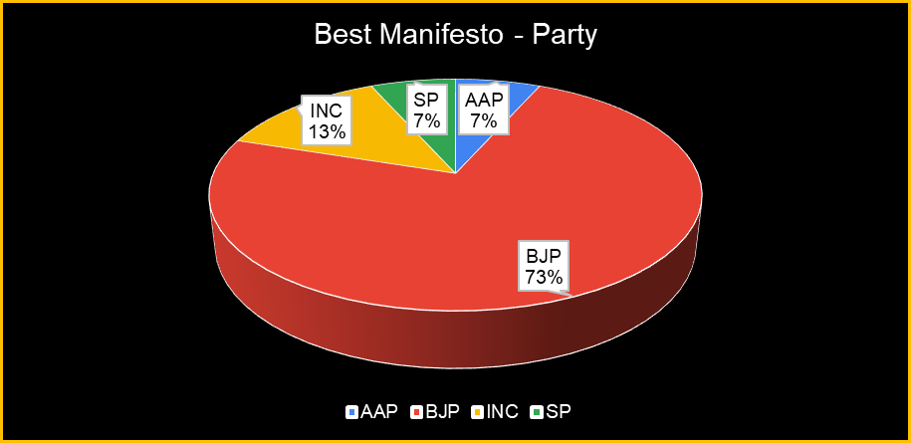

* Women feels safe in Current Govt.

